Project: Moffat Bay
Course: CSD 460
Description: Tests for the Landing Page
Date: 9/2/2026
To complete the test case plan, fill out the information for Project, Course, Description and Date in the header below.
.
Contents
No table of contents entries found.

For each test, the developer should: provide a test description, a test objective, the developer name and date tested. For each step, fill out the actions to be taken and describe the expected results, and indicate yes or no for each step depending upon the result. The peer tester should provide their name, date tested, indicate yes or no for each step depending upon the result, and a screenshot (thumbnail) of the result.

Test 1 | Landing Page Loads With Production Navigation and Script
 | Test Objective: Verify that the Moffat Bay landing page loads successfully and contains the required production navigation, room section, booking links, and JavaScript without references to the removed mock files. | Developer: Tiffany Davidson  Date tested: 2026/09/02 | Peer tester: Matthew Rozendaal  Date tested: 2026/09/02
Step | Action | Expected results: The landing page loads successfully with the required production content and navigation. The landing.js script is included and the removed mock-data.js, api-contract.js, and app.js files are not referenced. | Developer pass/fail | Tester pass/fail  + Screenshot
1 | 1. Start the Moffat Bay Python landing-page server. |  | Yes | Yes
2 | 2. Navigate to http://127.0.0.1:8000/. |  | Yes | Yes
3 | 3. Verify the landing page loads successfully. | 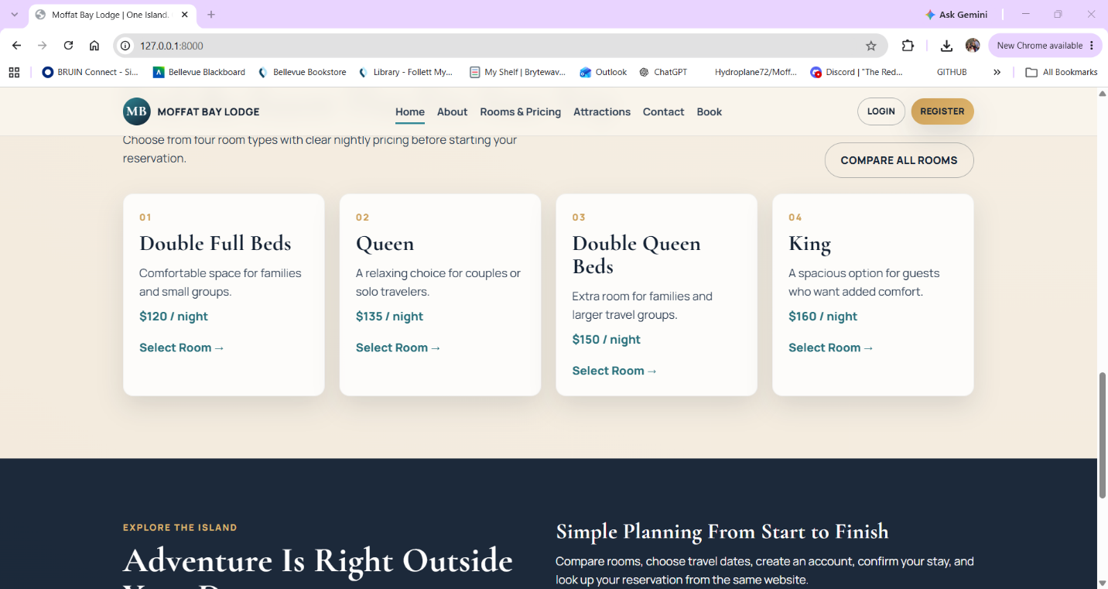 | Yes | Yes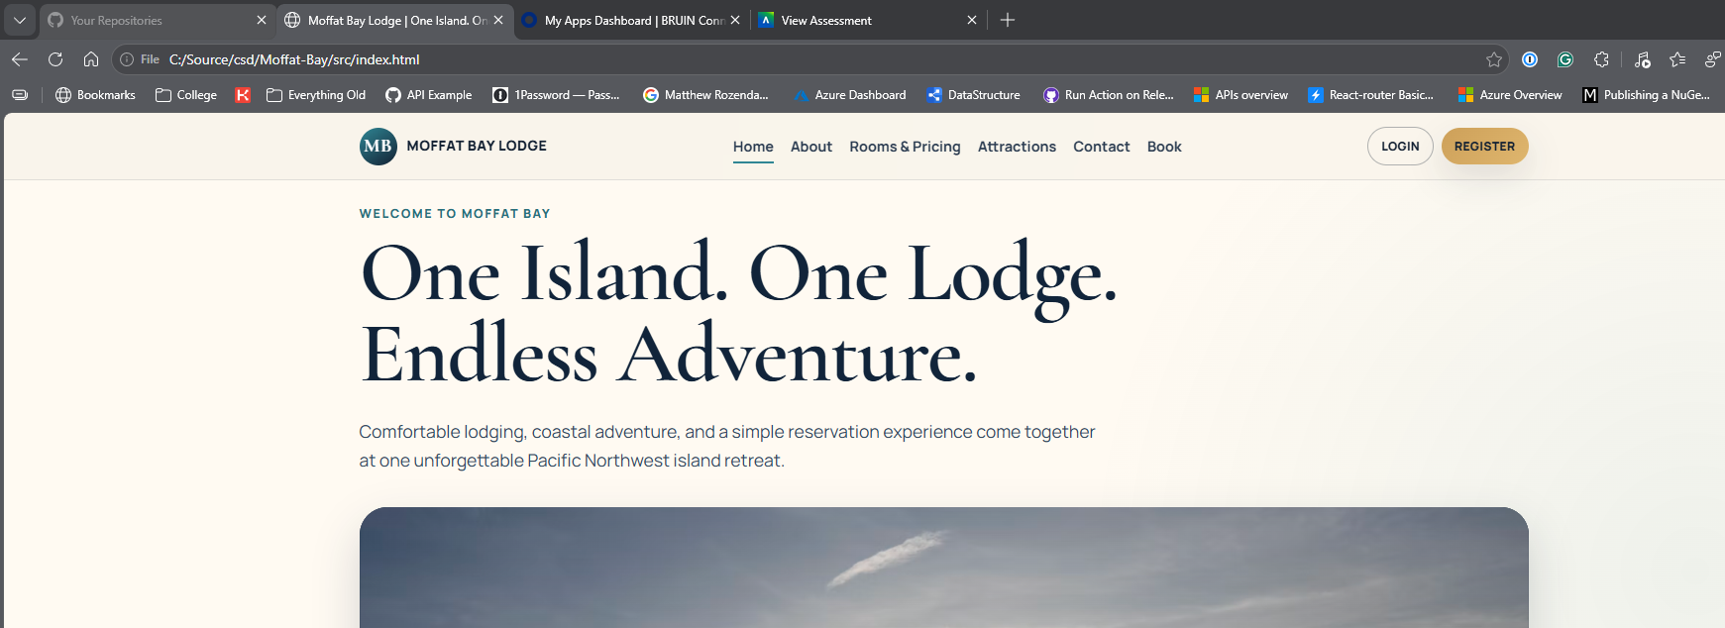
4 | 4. Verify the navigation menu, login/register controls, room cards, room pricing, and booking links are displayed. |  | Yes | Yes
5 | 5. Run the automated FT-LP-01 pytest test. |  | Yes | Yes 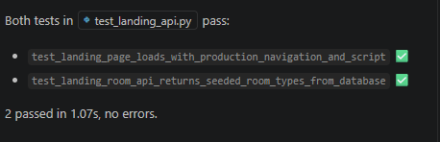
Comments | A later update after these tests were made allows for localhost viewing of the pages to be ablet o hit the python apis

Test 2 | Landing API Returns Seeded Room Types From Database
 | Test Objective:  Verify that the landing-page Python backend successfully connects to the Moffat Bay MySQL database and retrieves the room types used by the landing page. | Developer: Tiffany Davidson  Date tested: 2026/05/02 | Peer tester: Matthew Rozendaal  Date tested: 2026/05/02
Step | Action | Expected results: | Developer pass/fail | Tester pass/fail
1 | 1. Start MySQL through XAMPP. |  | Yes | Yes
2 | 2. Start the Python landing-page server. |  | Yes | Yes
3 | 3. Navigate to http://127.0.0.1:8000/api/landing/room-types. |  | Yes | Yes
4 | 4. Verify that the API returns the four seeded room types. |  | Yes | Yes
5 | 5. Verify that the nightly prices match the RoomTypes table. |  | Yes | Yes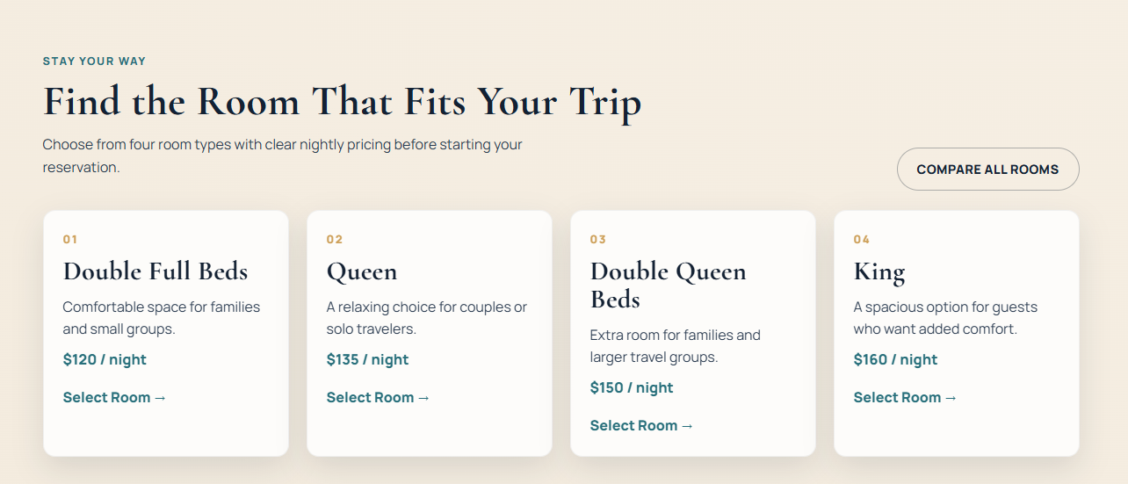
 | 6. Run the automated FT-LP-02 pytest test. |  | Yes | Yes
Comments | A later update after these tests were made allows for localhost viewing of the pages to be ablet o hit the python apis

